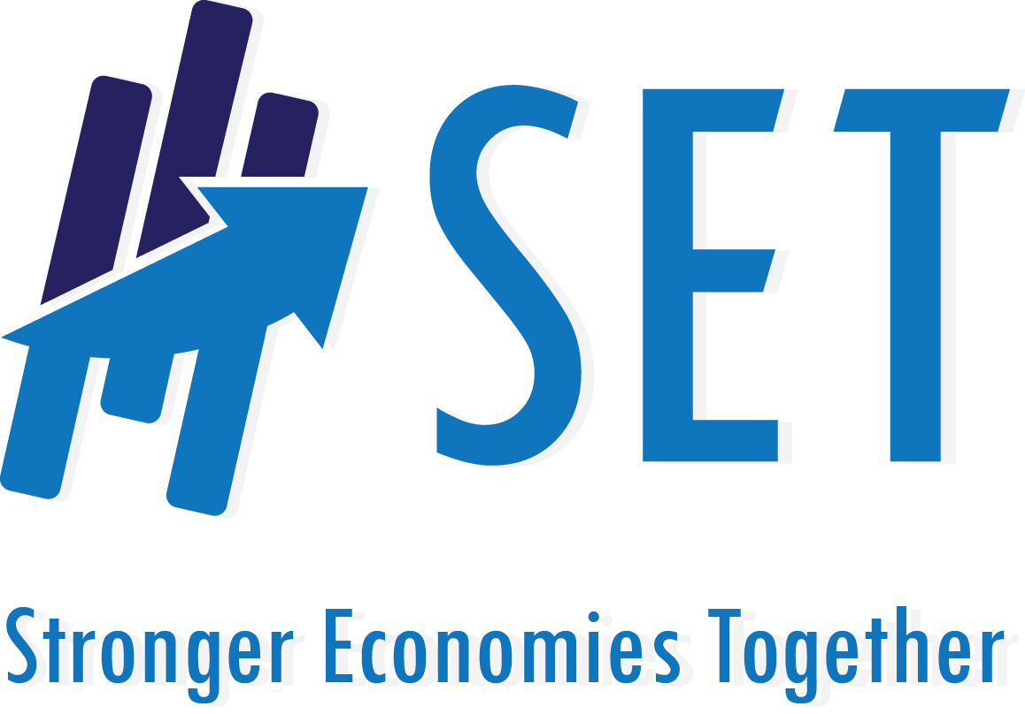

Regional Application
2017

About the Stronger Economies Together (SET) Program: In many counties, especially those with smaller populations, finding ways to create, attract, and retain jobs is a challenging process. Pursuing economic development as a single rural county in isolation from other nearby counties is oftentimes unproductive. In today’s global marketplace, economic development improvements are more likely to be realized when rural and metro counties work together as a multi-county region to assess, design, and implement plans that build on their assets and comparative economic strengths. That is what the Stronger Economies Together (SET) is all about.

Purpose: The purpose of SET is to strengthen the capacity of communities/counties in rural America to work together to develop and implement an economic development blueprint for their multi-county region, one that strategically builds on the region’s current and emerging economic strengths.

Project Partners: Stronger Economies Together is a partnership among the Cooperative Extension Service, USDA Rural Development, the four Regional Rural Development Centers with leadership from the Southern Rural Development Center, USDA National Institute of Food and Agriculture (NIFA), and the Purdue Center for Regional Development

Eligible States/Regions: Regions located in the following states are invited to take part in Phase VII of the SET program:

Arkansas
Indiana
Missouri
New Mexico
North Carolina
Oklahoma

What Types of Regions Are the Most Likely to Benefit from SET? Regions have entered the SET program from a variety of starting points. Some regional groups are newly formed, while others have been in place for an extended period of time. Some SET regions may be subsets or overlap with Economic Development Districts (EDDs), but are formed to develop an economic development blueprint that provides more focus on a particular sector or set of issues. While SET is particularly appropriate for newly forming regions, it can also be helpful for more established regions that are interested in updating or rewriting existing plans, such as a Comprehensive Economic Development Strategy (CEDS). Successful SET regions share five important features and as such, regional team members are urged to fully embrace the following attributes:
- Recognition that regional strategies represent a key part of the overall economic development blueprint for the region’s small communities, cities, and counties;
- Openness to exploring economic activities that focus on strengthening a core of existing or emerging economic clusters that can expand the economic vitality of the region while emphasizing rural-urban connection;
- Awareness of and willingness to collaborate with existing regional partnership and planning efforts, such as Economic Development Districts.
- Commitment to gathering inputs and insights from a diverse and representative set of institutions and people when determining the region’s goals and plans, going well beyond a reliance on economic development professionals and elected officials;
- Willingness to take a fresh look at where the region is, where it wants to go, and the best way to get there;
- Commitment to devote significant time and energy needed to: (a) actively participate and work through all SET planning materials as a regional team; and (b) use this process to develop a High Quality regional economic development Plan (HQP) that is developed and implemented by the regional team and appropriate partners.

The SET Process – Three Important Components:
- Planning Process: A Key Component of the SET Program: The SET program includes a civic forum, along with a set of modules tailored to each region’s particular needs. The discussion and application of the modules are facilitated with each regional team on a face-to-face basis. State Resource Teams, made up of representatives of your state’s land-grant university-based Extension Service, state USDA Rural Development staff, and other key partners, will coach the SET planning process and serve as resource persons to your region. Approximately 20+ hours of active facilitated coaching will be provided to each region over the course of several months. Selected regions are expected to actively participate in the entire process. More information about the stages of the process is available at: http://srdc.msstate.edu/set/files/set_overview.pdf.

- The High Quality Plan: A Critical Component of the SET Program: The SET planning process is a means to an end. The end, of course, is a region with a stronger economy. Regions that join SET are expected to develop and implement a High Quality Plan (HQP). The attributes of a HQP are available at: http://srdc.msstate.edu/set/high_quality_ed_plan.html. Creation of a HQP positions the region to implement a sound plan that contributes to a stronger economy.

- Technical Assistance to Begin Implementing the Plan Available to Regional Teams: In addition to facilitating the SET process, the State Coaching Team will provide in the range of 20 to 40 hours of technical assistance to your region for a period of 6-12 months once your team has completed its SET planning process. By technical assistance, we mean that Extension educators and USDA RD State staff will assist your team in securing the type of information (e.g., data, expertise, advice), or provide facilitation or additional coaching on a topic, if needed, to guide your regional team as you begin to implement your High Quality Plan (HQP). This includes securing the help of university colleagues or USDA RD state staff members who may have the background/expertise needed by your team.

Major Benefits to Successful Applicants: Each selected region will receive many important benefits including:
- Coaching on the core building blocks that will serve as the foundation for developing and launching your region’s HQP.
- In-depth data that are tailored to your region, information that helps delineate the critical drivers of your economy (including the presence or emergence of regional clusters).
- Tools that uncover local assets and resources that can be tapped to advance your region’s economic strategies and actions.
- Technical assistance from Extension educators and USDA RD State staff to guide your region as it begins to implement its HQP.

Definition of “Region” and the Rural Requirement: Each region must encompass three or more contiguous counties (with some exceptions for Tribal areas) and the total population and/or geographic area of the region must meet one of the following requirements: (1) at least 51% rural in nature; OR (2) 75% of the region’s land area is located in rural areas of that region. Regions may cross state boundaries as long as the counties that make up that multi-state region meet the rural requirement. Also, counties separated by water (i.e. Hawaii) will also be considered contiguous.

For purposes of this application, rural refers to counties that are classified as nonmetropolitan areas by the Office of Management and Budget. Nonmetropolitan areas can be either micropolitan or noncore counties. This information can be downloaded from the following SRDC web site: http://srdc.msstate.edu/set/definitionrural.html

Priority Points for Economically Distressed Regions: Priority points will be given to regions that include at least one economically distressed county as defined below. Evidence must be included within the application indicating that the priority county(ies) are ready to take an active role.
- Definitions:
  - Economically distressed is defined as an area that has:
    - A per capita income of 80% or less of the national average; and/or
    - Has an unemployment rate that is, for the most recent 24-month period for which data are available, at least 1 percent greater than the national average unemployment rate.
- Data for economically distressed areas can be found at:
http://www.statsamerica.org/distress/distress.aspx
- Select your state, then select your proposed counties one at a time and click “add county” until all appear in the box.
- Click Distress Report to see Economic Distress Criteria Primary Elements.

Deadline Date for Applications: Applications are due electronically no later than March 3, 2017 by 11:59 p.m. local time. Please submit your application to: Gregory Batson and Sharon Gulick (see contact information below). You will receive an acknowledgement of your application within two business days. We urge all applicants to contact us immediately if they have not received an acknowledgement within this time period.

All applications will be carefully studied by the State Resource Team representing the state’s USDA Rural Development (RD) office, Cooperative Extension Service, and other key community/economic development organizations or agencies in your state. The State Resource Team may contact applicants in order to conduct site visits and a tour with representatives of your group. Once the State Resource Team has completed its evaluation of all SET applicants, it will submit its recommendations to the national USDA RD office. Key representatives from USDA RD, the Regional Rural Development Centers and the Purdue Center for Regional Development will review the national pool of finalists. The national USDA RD Office will make the final decision regarding regions in each of the target states that will be invited to be part of the SET program. This announcement is expected to take place in late spring 2017.

Questions?
If you have any questions, please contact:
Sharon Gulick Gregory Batson
University of Missouri Cooperative USDA Rural Development, Missouri
Extension Service gregory.batson@mo.usda.gov
gulicks@missouri.edu Phone: 573-876-0977
Phone: 573-884-0669

How Proposals Will Be Scored

All proposals will be scored on a 200 points basis. The following details the maximum amount of points associated with each component of the SET application. Please note that in addition to the scores associated with each SET application, USDA RD will be looking for other key elements in the selection process, such as regions with: (a) a different mix of recent regional work history; (b) varying levels of rurality; (c) different economic characteristics; (d) crossing state lines; (e) varying levels of social and demographic features (i.e., high poverty, population migration patterns, and racial/ethnic changes). These additional elements are intended to ensure that a good mix of regions is part of the SET program.

Please note that incomplete proposals will not be scored.

Maximum Points Possible
Description provided of your economic region (Part B) 15
Description of history of working together, including awareness of and/or partnership
with other regional economic development planning efforts (e.g., CEDS) (Part C) 15
Discussion of challenges of pursuing a regional plan (Part D) 50
Discussion of the region’s interest in the SET initiative (Part E) 50
Diversity of people/organizations that have committed to be on your SET team (Part F) 50
Priority Points: Economic Distress 20

TOTAL POINTS 200

USDA is an equal opportunity provider, employer and lender.

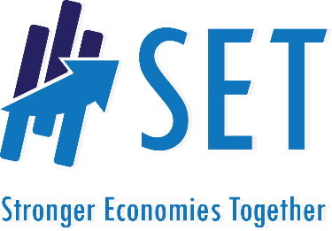
APPLICATION FORM
Missouri
Stronger Economies Together Program
Deadline for Applications: March 3, 2017, 11:59 p.m. Local Time
Please Complete All Sections of the Application Form

Part A: Information about Your Regional Team

- Name of your Regional Team (if none has been decided yet, just provide a name that best describes the geographic area of your regional group).
________________________________________________________________________________

NOTE: For purposes of this application, a region is defined as an area that encompasses three or more counties that are contiguous to one another. It is acceptable for your region to cross state boundaries or water barriers.

- What counties are included in your region?______________________________________________
_________________________________________________________________________________

- Main contact person for your regional team:_____________________________________________

Please indicate whether:
- Email address:_____________________________________________ Business OR Personal

- Telephone number: _________________________________________ Business OR Personal

- Mailing address: Business OR Personal _________________________________________________________

- Please place an “X” by the ONE statement that best describes your regional team.

Our regional team:
Is brand new and has been organized for the purpose of applying for the SET program

Has been organized for more than one year, but is inactive and/or in need of help to get back on track

Is less than one year old and is still trying to get off the ground in developing a sound regional economic development plan

Has been in place for one year or more and has developed OR is pursuing an effective regional economic development plan. The group is open to reconsidering all aspects of the plan

Part B: Brief Economic Description of Your Region (250 word limit)

Present an overview of why the proposed area is an economic region and the sectors that represent key drivers of your economy. Here are the types of information you might include in your description:

- Economic region: Is this region an economic region? For instance, what evidence do you have that the counties in your region, taken together, constitute an economic region (or an emerging economic region)?
- Potential: What kind of opportunities exist in the region that would be helping to improve the economic resiliency and self-sufficiency of the regional economy?
- Key sectors that make up your economy and the current health of these sectors: In general, tell us about how the economy of your region is doing and why. Are your key industry sectors stable, expanding, declining, or mixed in terms of their performance?

Part C: History of Working Together in the Region (250 word limit)

Please describe your regional team’s past history of working together on economic development issues. What have been your successes, if any? What have been your challenges or barriers, if any? Please describe any previous planning efforts among the regional team members including dates and counties involved. If your proposed region overlaps with an existing Economic Development District(s), please describe which of your counties overlap with the EDD region, when their CEDS plan was last completed or updated, and how you intend to coordinate/collaborate with the EDD. Please attach to this application support letters from the EDD, if applicable. If any counties in your region participated in previous SET trainings, please describe the time/phase of training, and why these counties would like to participate in SET again. If your region has no history of working together, please describe any barriers that have prevented efforts to collaborate in the past. Please note that points are not awarded for the volume of your past history, since SET is ideal for new groups. Rather, points are awarded for the completeness and clarity of the description.

Part D: Challenges of Pursuing a Regional Economic Development Plan (250 word limit)

In Part C, you discussed the history of working together across your region. In this part, please focus on the future and, specifically, what you anticipate will be some of the key challenges that your team will face as it seeks to develop and launch a regional economic development plan. Please address how you may resolve these issues. For instance, consider potential challenges related to:
- Recruiting a large and diverse regional team that will work together through the entire planning process
- Insuring rural-urban connection when applicable
- Developing a regional mindset
- Implementing the plan
- Committing the time required to be part in SET
- Other key challenges your region believes it may encounter

Part E: Interest in the SET Initiative (400 word limit)

- Explain why your regional team would like to be part of the SET program. What are the primary factors influencing your interest in SET right now?
- Who has expressed interest and why?
- What do you hope/expect will happen in your region due to your participation in SET?

Part F: Current Members of Your Regional Team and Commitment Letters
Please provide the names of the individuals and their respective organization/agency affiliations that have agreed to be part of your regional team. More effective regional teams include representation from many sectors. Applications with broad representation will score higher. ALSO, a signed commitment letter from each person on your team that states that he/she has agreed (1) to actively participate in the SET planning process and (2) to honor the commitments stated below must be included with this application.

Name of Regional Team Member | Primary Organization/Agency the Person Represents | Have Commitment Letter from this Person?
  - Yes
  - No
  - Yes
  - No
  - Yes
  - No
  - Yes
  - No
  - Yes
  - No
  - Yes
  - No
  - Yes
  - No
  - Yes
  - No
  - Yes
  - No
  - Yes
  - No
(Feel free to attach a separate sheet if needed to add more Regional Team members)

Commitments: Success of SET depends on the commitment of all regional team members to the following:
- Recognition that regional strategies represent a key part of the overall economic development blueprint for the region’s small communities, cities, and counties;
- Openness to exploring economic activities that will focus on strengthening a handful of key existing or emerging economic clusters in the region and improving the resiliency and economic sufficiency of the regional economy;
- Awareness of and willingness to collaborate with existing regional partnership and planning efforts, such as Economic Development Districts (EDDs).
- Commitment to gathering inputs and insights from a large diverse set of institutions and people when determining the region’s goals and plans;
- Willingness to take a fresh look at where the region is, where it wants to go, and the best way to get there;
- Commitment to devoting the significant time and energy needed a) to actively participate and work through the entire SET planning process as a regional team; and b) to use this process as the foundation for a High Quality regional economic development Plan that is developed and implemented by the regional team.

